Model  Product picture | 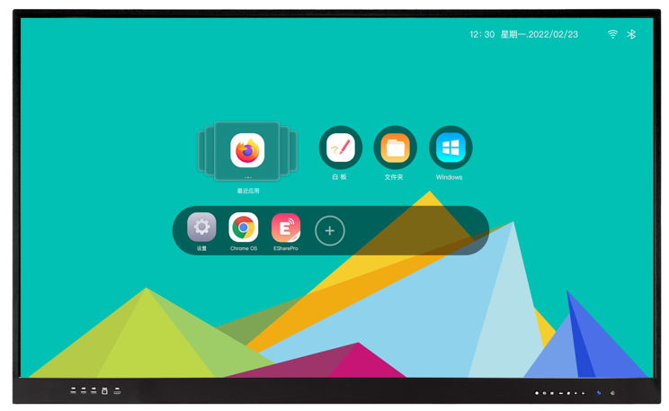
Display specification
Diagonal display size | 86"
Active area (mm) | 1895.04 * 1065.96(V)
Pixel Pitch | 0.4935 mm x 0.4935 mm
Bezel color | Aluminum frame Black color
Back Light | Direct type LED (D-LED)
Resolution | 3840*2160 /60hz
Aspect Ratio | 16:09
Contrast Ratio | 4000:1
Colors | 1.07 billion colors
Brightness | 450cd/m2
Viewing angle | 178°
Glass hardness | Mohs-7 level
Screen surface | Anti-Glare glass
Panel Interactivity
Touch technology | IR touch
Multi touch | 20 points(20 points in Android & 40 points in Windows)
Auto-calibrate | Yes
Anti-light | Yes
Minimum object size | 3mm
Accuracy | 1 mm (over 90% Area)
Response Time | <8 ms
System support | Windows 7/8/10; Android; Mac; Linux; Chrome OS
Front side Connectivity
USB | 3
TOUCH USB | 1
HDMI 2.0 INPUT | 1
Front keys | Power on/off; Signal source; Return; Main page; Menu; Volume down; Volume up
Speaker | 15W*2
USB-C (15W full function with PD charge) | 1
Rear/Bottom side Connectivity
VGA IN | 1
PC Audio IN | 1
YPBPR | 1
Earphone | 1
AV IN | 1
AV OUT | 1
MIC IN | 1
RS232 | 1
SPDIF | 1
USB 3.0 | 2
USB 2.0 | 1
HDMI 2.0 IN | 2
USB-C (5W for data) | 1
SD-CARD | 1
RJ45 IN | 1
RJ45 OUT | 1
Touch USB | 1
WI-FI | 1*2.4G，1*5G
DP | 1
HDMI OUT | 1
Windows OPS Slot | 1
Operating system
Android Version | Android 11.0
CHIP | Amlogic T982
CPU | A55*4 @1.9GHz
RAM | 4GB DDR4 (8GB option)
ROM | 32GB (64GB option)
GPU | G52 MP2
Decoding resolution | Support 4K H.265 decoding
Video format | Support VP9, HEVC/H.265, MPEG1/2, MPEG4, Sorenson H.263, H263, H.264, AVS, AVS+, AVS2, WMV3, VC1, Motion JPEG, VP8, RV30/RV40, AV1 and other video formats
Image Format | Support JPG/JPEG/BMP/PNG and other image formats
audio format | Support MPEG1/2, AC3, EAC3(DDP), AAC, HEAAC, WMA, WMA10 pro, M0, WMA10 pro M1, WMA10 pro M2, VORBIS, LPCM, IMA-ADPCM, MS-ADPCM, LBR, FLAC, DRA, OPUS, AC4, MPEG-H TV and other audio formats
Physical specifications
Net Weight (kg±2) | 65
Gross Weight (kg±2) | 80
Overall size(mm) | 1943.4*97.5*1166
Carton size(mm) | 2090 *222 * 1307
VESA | 800*600
Electrical
Input Voltage | 100-240V AC
Switch on or off | Yes
Power Consumption(Standby) | <0.5W
Power Consumption | Maximun< 500W, Eco<75W
Accessories
Accessories | WIFI antenna; No ink pen * 2pcs, Remote control *1pcs, 1.5m power cord *1pcs, 1.5m HDMI cable *1pcs, 1.5m USB touch cable *1pcs; wall mount kit

